THE VILLAGE INTERNATIONAL BSCHOOL

Ch -5- Geometry - Revision Worksheet
Worksheet No: Subject: MATHS
Name: ……………………………………… Date:
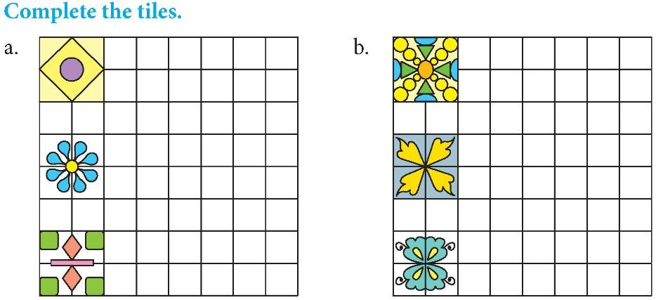
THE VILLAGE INTERNATIONAL BSCHOOL

Ch -5- Geometry - Revision Worksheet
Worksheet No:
Name: ……………………………………… Date:
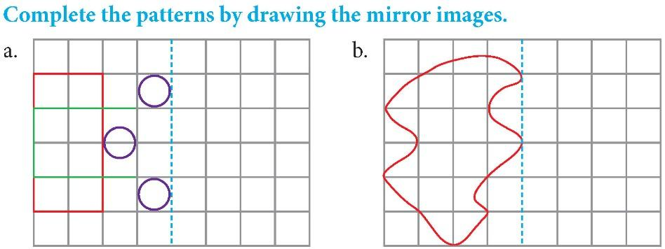

THE VILLAGE INTERNATIONAL BSCHOOL
Ch -5- Geometry - Revision Worksheet
Worksheet No:
Name: ……………………………………… Date:

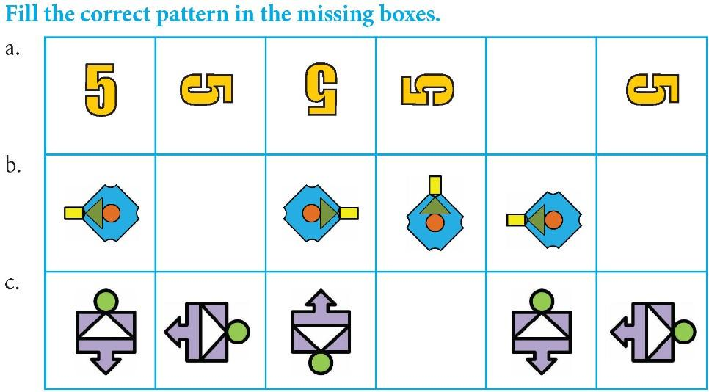

THE VILLAGE INTERNATIONAL BSCHOOL
Ch -5- Geometry - Revision Worksheet
Worksheet No:
Name: ………………………………………

THE VILLAGE INTERNATIONAL BSCHOOL
Ch -5- Geometry - Revision Worksheet
Worksheet No:
Name: ……………………………………… Date:
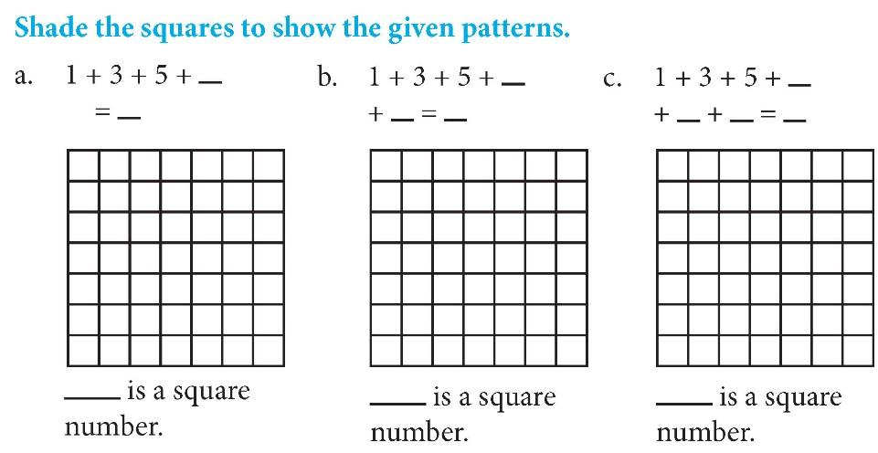

THE VILLAGE INTERNATIONAL BSCHOOL
Ch -5- Geometry - Revision Worksheet
Worksheet No:
Name: ……………………………………… Date:

